BN, June 2020

Surcharge Automation

Customer: Round Ground

Phase 2:

I/ Fix EDI Parser to add Line User 5 to the Surcharge line as a reference tied to the main line

II/ Modification of Custom Order Line:

1. Use the Script 2 button at the Sales Order Line screen instead of the Exit/Close button to open the custom line screen.
2. Add column Cust Due Date to the custom line screen. Functionality will be the same as the Ship Date column.
3. Add column Approve (checkbox type) to the custom screen. This will give the ability to check as Approve that link to project 4271.
4. Add the Available Qty to the custom screen.
5. Add column with inline button Allocate when clicked will open the Part Allocation screen.
6. When option User Fields Required/Validated are turned off at the Sales Order line, the program should display the message, but still allow to upload.
7. Add the Save button on the custom screen. If user adds/changes something from the custom screen without clicking the Save button, then when closing, a message will pop up asking if user wants to save.

**I/ EDI Parser for Surcharge:**

Order Entry > File > Order Entry from EDI Transactions

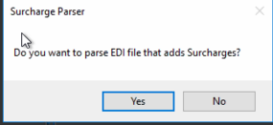

Click Yes: you will select the original file and parse that file into another file that later be used for EDI upload.

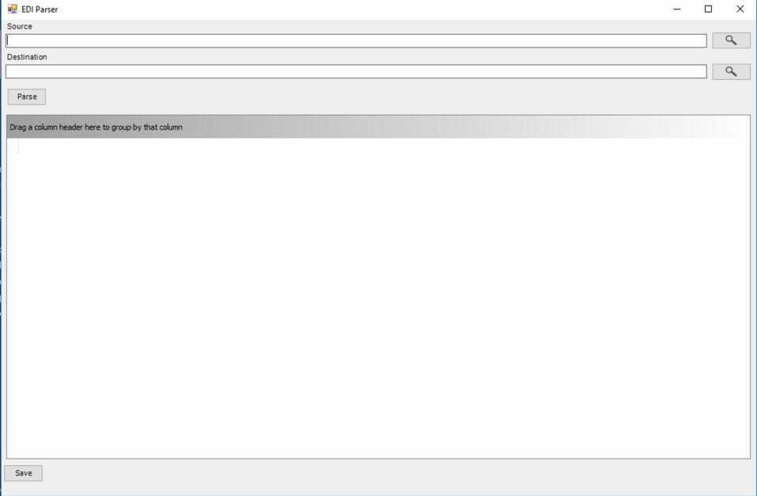

Browse the source:

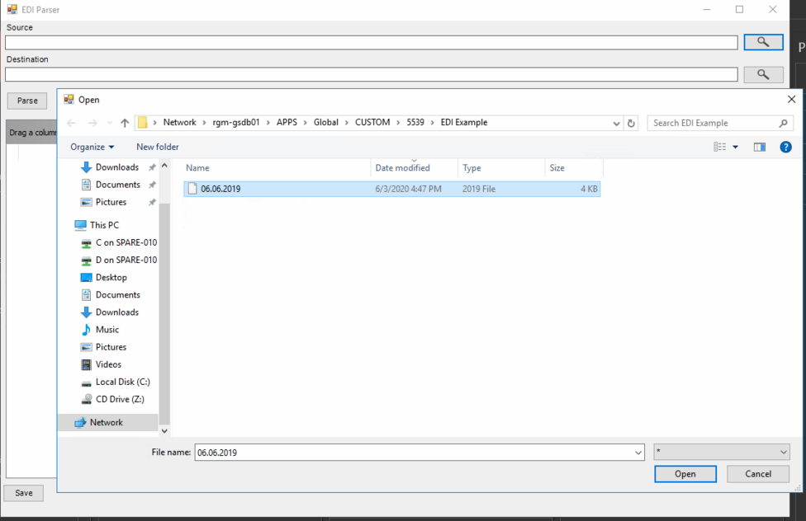

Select the source file. The program will generate a Destination name:

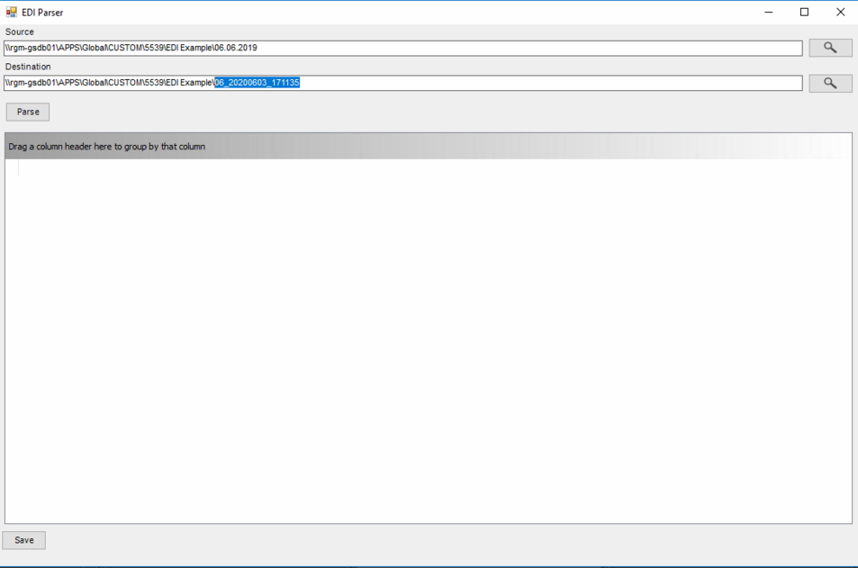

Click Parse

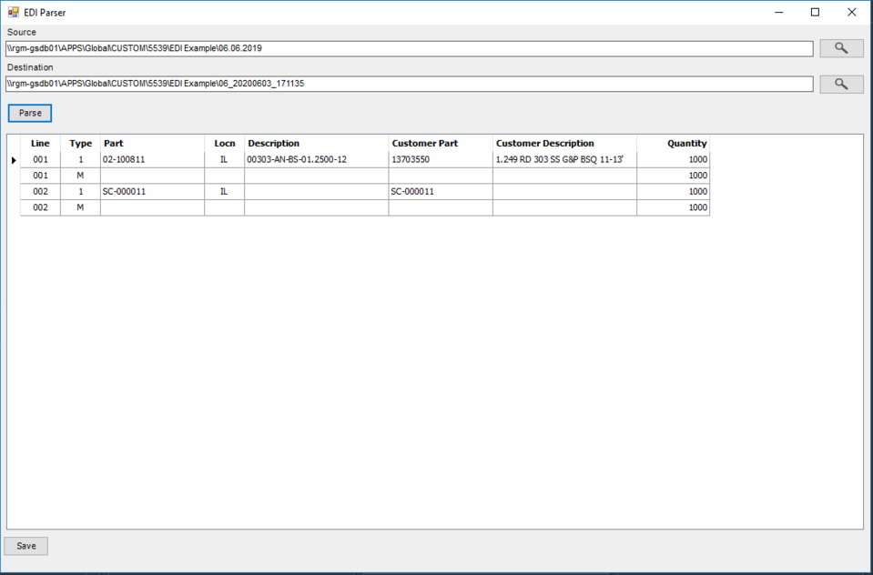

Click Save, the program will proceed to core screen:

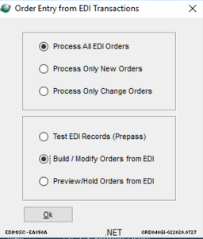

Click OK, the program will ask you the file to upload, it pops up a browser to select the file to upload. Select the new file parsed from the original file which is 06_20200603_171404. Notice that the original file is now renamed with suffix _Parsed.

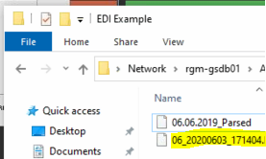

Proceed the EDI process as normal. Here is result with the order uploaded:

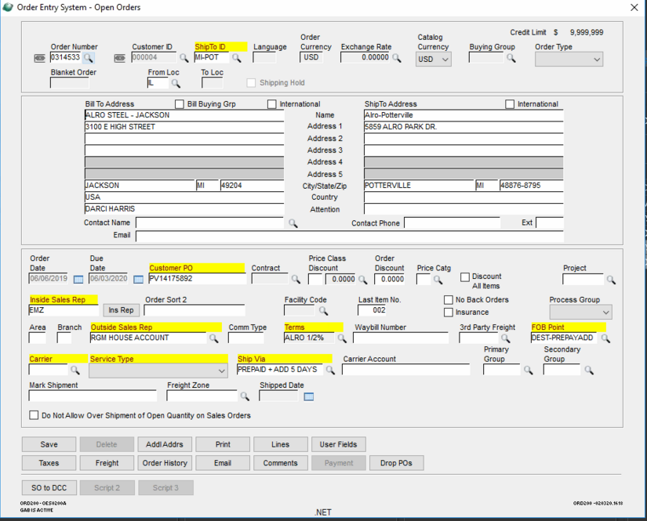

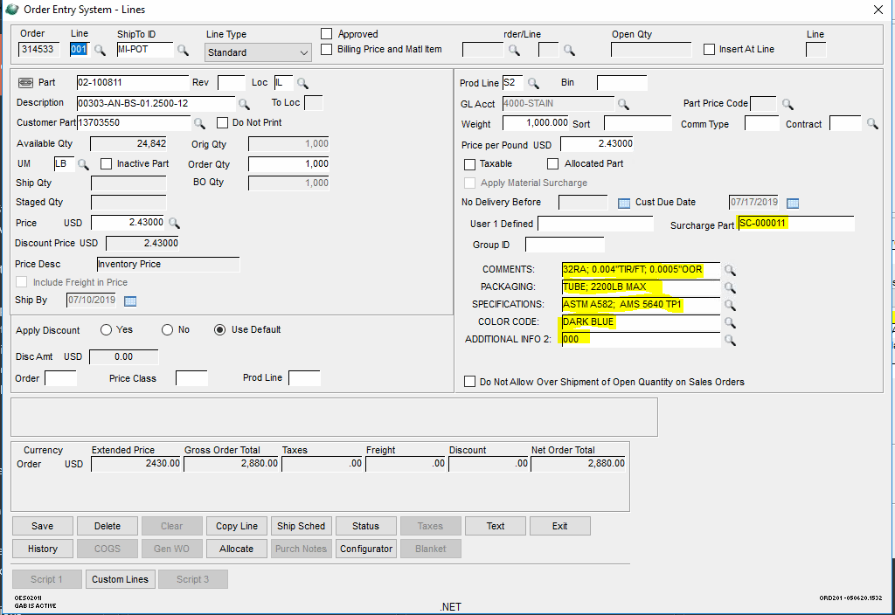

Core EDI takes care of the User defined 1 & 2(copied from inventory master of the part), and User fields 1, 2, 3, 4.

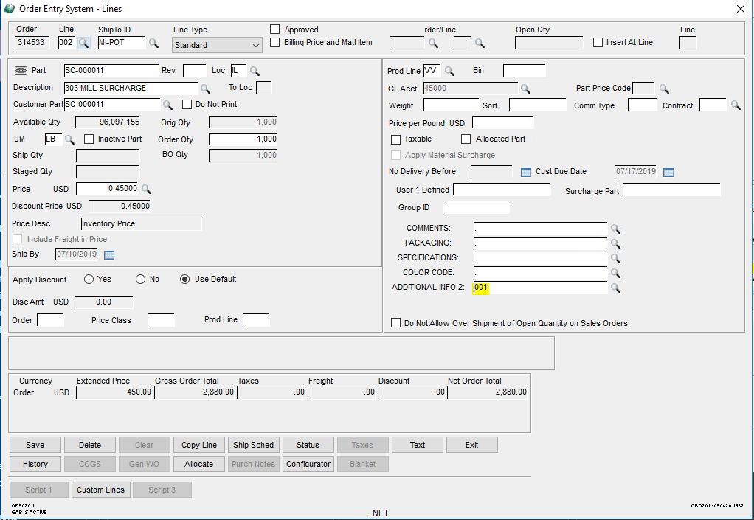

Custom program takes care of the User field 5 for the Surcharge, that puts in the line number of the main part that the surcharge ties to, in this case it is 001

**II/ Modification of Custom Order Line screen:**

This is the new screen for the order entry:

